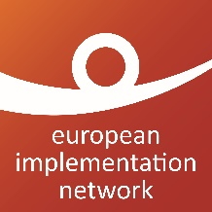
EIN and NHC Training for civil society organisations on implementing judgments of the European Court of Human Rights in Ukraine
Training
October 2021

Application Form
Please send the completed application form by 16th September 2021 to hrd@nhc.nl

Dates for the event: The decision on whether the event is organised in Kiev or online will be taken early September.
If in-person meeting: 26th October 2021 afternoon -27th October 2021 whole day. On 28th October whole day, a seminar about the implementation of ECtHR judgments will be organised: all participants in the training are invited to attend this event (see the call for applications for further details).
If online event: 26th, 28th and 29th October 2021 afternoon (14.00-17.00, Ukrainian time)
Family Name
First Name
Nationality
Organisation name and website
Your role in the organisation (function)
Country where you are based
Telephone
Mobile phone
Email
Preferred means of communication (Skype, Telegram, Signal)
GDPR statement  EIN and NHC will never sell your data and use them for purposes other than the ones you agreed with above. | ☐ I agree that the organisers use my contact details to reach out to me in view of preparing my participation in the event I have applied for, should I be selected  ☐ I agree to be informed about any future events on ECtHR judgments implementation organised by EIN

Selected participants will be invited to fill in a questionnaire, ahead of the training, to detail their experience in the implementation process and expectations on the training.

